Illicit Drug Trafficking through the Caribbean and its Impact on EU Drug Markets: the case of the Lady Michelle

©Daurius Figueira
March 5, 2017

The 4,240 kilo Drug Bust in the Atlantic north of Suriname in Context
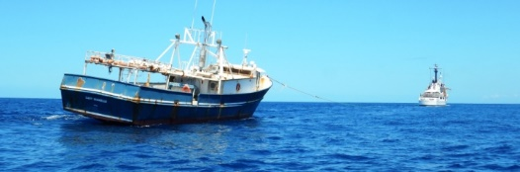
Lady Michelle (NCA)
The interdiction of the fishing vessel “Lady Michelle” in international waters of the Atlantic north of Suriname with 4.2 tons of cocaine on board by a US Coast Guard cutter supported by a vessel from the T&T Coast Guard on February 16, 2017 is but another illustration of the reality on the ground that politicians don’t speak about. The online news report from the US Coast Guard News, February 27, 2017 stated that the US DEA St Croix was the lead investigative agency in the case which explains why the four Guyanese nationals arrested on board the Lady Michelle were dropped off in St Croix in the hands of US Federal authorities there. The Lady Michelle was registered in St Vincent which explains why it was towed by the US vessel and placed in the hands of the Coast Guard of St Vincent. The 4.2 tons of cocaine valued at USD 125 million at wholesale value was offloaded at US Coast Guard, San Juan, Puerto Rico. Finally, US Coast Guard news reported that the National Crime Agency (NCA) of the UK was involved in the operation.
http://coastguardnews.com/coast-guard-offloads-125-million-worth-of-seized-cocaine-in-puerto-rico/2017/02/27/
The NCA in an online press release of 28 February 2017 stated that it was 4,240 kilos of cocaine in 185 bales seized from the Lady Michelle or 4.2 tonnes not 4.2 tons as in the Us Coast Guard news report with a wholesale value in Britain of 150 million UK Pounds. More importantly the NCA insisted that the load of the Lady Michelle was headed to West Africa. This position points to an operational reality involving the Caribbean island chain, the Caribbean Basin and the Atlantic that has a range of impacts on the nation states in these regions just another gift from Pax Mexicana!
http://www.nationalcrimeagency.gov.uk/www.nationalcrimeagency.gov.uk/news/1032-international-operation-nets-huge-atlantic-cocaine-haul
A Guyana Chronicle online report dated March 1, 2017 stated that prior to the interdiction of the Lady Michelle the Guyanese authorities were tracking another vessel in Guyanese waters off the Corentyne coast moving north which they interdicted in the vicinity of Shell beach, brought into the Waini River searched and release with its crew of one Guyanese national and five Spanish speaking foreign nationals. There is the view that the vessel intercepted in the vicinity of Shell beach, Guyana delivered the cargo of 4,240 kilos of cocaine to the Lady Michelle and the Guyanese authorities failed to detect and interdict the Lady Michelle. The report stated that the then head of CANU indicated that there were no records to show that the Lady Michelle left Guyana prior to its interdiction or has been in Guyana since 2015 non-elected political discourse at its best. The report names the four arrested and charged Guyanese with the captain of the 70-foot fishing vessel Lady Michelle being also Guyanese. This was a transnational illicit trafficking operation utilising Guyanese personnel and Caribbean resources.
http://guyanachronicle.com/2017/03/01/probe-into-cocaine-ship-likely-suspected-transfer-vessel-held-by-local-agents-raises-concerns
Can the 70-foot Lady Michelle make the run to a point off the coast of West Africa where the load will be handed over to transporters whose task is to make the run to the coastline, land the shipment, transport, warehouse and guard? Yes! The major issue is fuel and the best deal possible is to stock up on fuel in Trinidad as Venezuela is now dicey even for the transnational traffickers on the ground as trust and integrity is a precious commodity. If you choose to run along the Eastern Caribbean Trafficking Pipeline (ECTP) before heading eastwards then you can top up at a fuel dump within the ECTP but to do this with impunity you must be connected, you must be a sanctioned trafficker if not then the DEA and the NCA can and will miraculously receive vital information on your shipment life’s a bitch in a US Federal facility where gangland affiliates of Pax Mexicana are in there with you 24/7, 365 days for every year of your time served. Pax Mexicana! The reality we will never know is the capacity of the Lady Michelle to store fuel given the cargo of 185 bales of kilo bricks. If the capacity doesn’t exist in the fuel tanks, then barrels of fuel will have to be placed on deck and everywhere else and this is a dead giveaway for surveillance agencies. Was the Lady Michelle headed to the coast of West Africa or was to several possible drop off points on the coast of Western and southern Africa? In the traditional West African zone, you have Ghana, Guinea-Bissau, Senegal and Nigeria as some of the dominant spots but out of this zone there is now Angola as a growing reception point and the mother of all reception points is South Africa. There is also the possibility of a run northwards along the ECTP then an eastward run to the coast of West Africa then a northwards run to a rendezvous point with the transporters in international waters off the Canary Islands where the load is deposited within the boundaries of the EU. But the crucial issue is what is coming across the Atlantic via the pipeline to the Caribbean island chain and the Caribbean basin? As the loads cross the Atlantic from the Caribbean to Western Africa are the transports sunk upon completion of the run, redeployed in African markets or are a select few loaded with product for the return run? If so what, then is the product mix?
A DEA press release of January 21, 2017 reported on the extradition of individuals who are nationals of Kenya, Pakistan and India from Kenya to the US on indictment for conspiracy to smuggle heroin and methamphetamine to the US via a transnational illicit trafficking organisation. The meth is manufactured in Kenya and the heroin is sourced from Afghanistan thereby completing the product mix which is moved from Africa to world markets with the US market being a prime target. The four extradited from Kenya are: Baktash Akasha Kenyan national, resident of Kenya and head of the Akasha organisation/crime family, Ibrahim Akasha brother of Baktash Kenyan national and resident of Kenya, Goswami Indian national and resident of Kenya manager of the drug business of the crime family namely the production and distribution of methamphetamine in Kenya and the procurement and distribution of heroin from Afghanistan and Hussein national of Pakistan and resident of Pakistan a transporter of heroin by sea to various markets including Africa. The pairing of meth production with heroin smuggling must be noted given the willingness of the crime family to smuggle this product mix from Africa to US markets. The Mexican TTOs dominate the US heroin and meth markets at present and a crime family in east Africa seeking to challenge the Mexican monopoly must either be an affiliate of the MTTOs or face the fury that awaits those who choose to challenge this Mexican hegemony. Possibly the reason for the extraditions and incarceration in a US federal penitentiary system dominated by affiliates of the Mexican TTOs. The combination of meth and Afghan heroin indicates that this is the product mix of a Mexican affiliate who is moving this product mix to Europe. Already the Nigerian transnational trafficking organisations have combined meth with cocaine and heroin for the European markets and the MTTOs have passed the technology on to Nigerian and other African organised crime groups necessary to produce industrial grade ice/meth. The lesson then is Afghan heroin moving from Africa through the Caribbean island chain and the Caribbean basin on the way to US and Canadian markets. On these transports from Africa there is no need to move multi tonne loads of heroin given the wholesale market value of heroin in the US and Canadian markets. A very large shipment will be 200 kilos of heroin as quantities 20 kilos to 100 kilos are extremely profitable. There is also the space to maximise profitability by placing smuggled humans on the vessel who are paying prime prices for extremely discreet illicit entry to the island chain and/or the Caribbean basin. Think about the possible and probable range of such clients for the illicit service!
https://www.dea.gov/divisions/hq/2017/hq013117.shtml
The UNODC report “Afghanistan Synthetic Drugs Situation Assessment” January 2017 states that methamphetamine manufacturing facilities are now operational in Afghanistan and the synthetic drug is growing in availability on Afghan retail drug markets where it is being adopted by opiate users. Afghanistan is now in the grips of an evolving drug supply market where supply will beget demand. Again the growing link between the top illicit opiate producer and exporter in the world and a synthetic drug which is the flagship product of the MTTOs and experts on the production of industrial grade high potency affordable glass/ice/meth. The flood of high potency affordable heroin to US drug markets and the explosion of demand demands that the MTTOs form links and create affiliates with Afghan producers and traffickers of opium paste, opium and heroin. The business model and strategic plan demands no less.
http://www.unodc.org/documents/Reports/2017_Afghanistan_Synthetic_Drugs_Assessment_report.pdf
The illicit trades of South Asia are now linked to Africa and Africa is linked to the Caribbean basin which results in the linking of South Asia to the Caribbean island chain, the Caribbean basin and South America as this link is even more potent and voluminous in the case of Brazil. Illicit products from Africa to the Caribbean island chain across the Atlantic will utilise the same said trafficking points to enter the North Atlantic used in cocaine trafficking. In the Caribbean the smuggling of heroin to the US is affirmed by interdictions and the presence of crystal meth on the ground is reported as follows: A news report dated August 15, 2016 reported the interdiction of a heroin smuggler who arrived in Puerto Rico on an airline flight from the Dominican Republic, a news report dated August 18, 2016 reported the arrest for possession of crystal meth in Guyana and a news report dated September 30, 2016 reported on the threat posed by the trafficking of heroin and fentanyl from the Dominican Republic to the US. Heroin trafficking through the Caribbean island chain is then an established illicit enterprise with its pipelines into which the flows from Africa enter.
http://dominicantoday.com/dr/local/2016/8/15/Puerto-Rico-agents-nab-heroin-smuggler-on-Dominican-flight/
http://www.kaieteurnewsonline.com/2016/08/18/surinamese-found-with-large-quantity-of-illegal-drugs/
http://dominicantoday.com/dr/local/2016/09/30/dea-region-heads-dominican-antinarcotics-deal-with-heroin-fentanyl-crisis/
The Caribbean island chain, the Caribbean basin and Brazil are now poised to be impacted by the tsunami that is created in South Asia builds momentum in Africa, crosses the Atlantic and finally swamps the region. The transition zone for two flows of illicit products that are complementary to each other and controlled by the same transnational trafficking organisations with their partners and affiliates will pose the gravest threat to state survival ever experienced in their history both colonial and ex-colonial. Already the escalating gun violence in states that compromise the ECTP is the potent indicator of the changed order of the illicit trades and the explosion of value of the illicit trades: illicit poly drug movement, regional and international people smuggling operations, expansion and deepening of the product mix of small arms smuggling and the inclusion of a host of other illicit activities as fake pharmaceuticals, fake goods, ATM card skimming and payment card skimming and fraud. This is the legacy of Pax Mexicana!
The Alternate Reality
It is highly likely that the Lady Michelle with its illicit load was on its way up the ECTP to rendezvous with coast runners to supply product for eventual export via EU territories in the Eastern and Northern Caribbean to the EU namely the French, British and Dutch territories as Martinique, Guadeloupe, St Martin, Sint Maarten, St Eustatius, the British Virgin Islands, the US territories of Puerto Rico and the US Virgin Islands and the independent Caribbean states as Barbados, St Lucia and Antigua and Barbuda. The level of illicit activity within the ECTP is indicated by the nature of the interdictions reported, the staging of naval and military assets however inadequate to counter the trafficking threat and the action by the French government to ratify an extradition agreement with St Lucia and to enter into negotiations with the Commonwealth of Dominica for an extradition agreement in response to illicit trafficking between St Lucia and Dominica and Martinique and Guadeloupe respectively. The most illustrative instance of the intensity of the illicit activity within the ECTP was the assault on the hospital in Martinique by three armed men in December 2016 to ensure the escape from custody of the convicted international trafficker Walter Perez Caruso of Uruguay. This level of illicit activity is then reason enough to send the Lady Michelle loaded with 4, 240 kilos of cocaine up the ECTP which constitutes a grave threat to US and EU interests and it is now clearly apparent that the failure to respond to the threat posed by the illicit trades in the ECTP has fostered their evolution into a world class trafficking pipeline that is the ECTP. This reality is affirmed by the US committing two named naval and other unnamed assets to interdict the Lady Michelle as far south as the Atlantic coast of the north of South America. This is no operation Martillo, this is no Pacific operational theatre, this is not the fence of steel erected around Puerto Rico and the USVI. This is an operation to the furthest reaches of the theatre of possible operations necessary to protect US territories in the Caribbean island chain to boldly go where they have not gone since the decade of the 1990s now this expresses the gravity of the crisis exacerbated by the political paranoia generated by the new Trump war to destroy IS and T&Ts propensity to export migrants to IS. The links below will illustrate the intensity of the illicit trafficking in the ECTP presently:
https://www.thedailyherald.sx/islands/58850-dutch-vessel-seizes-128-kilos-of-cocaine
https://www.thedailyherald.sx/islands/61511-navy-intercepts-drugs-shipment
https://www.thedailyherald.sx/islands/63108-update-royal-dutch-navy-intercepts-large-drug-shipment-saturday
https://www.thedailyherald.sx/islands/57360-yacht-intercepted-with-588-kilos-of-cocaine-on-board
http://www.laht.com/article.asp?ArticleId=2418063&CategoryId=14092
https://www.ice.gov/news/releases/ice-caribbean-corridor-strike-force-partners-seize-60-million-worth-cocaine-marijuana
https://www.ice.gov/news/releases/ice-caribbean-corridor-strike-force-seize-1786-kilograms-cocaine
https://www.dea.gov/divisions/nyc/2017/nyc020817.shtml
http://stthomassource.com/content/2016/08/31/cocaine-sentence-gets-puerto-rico-man-126-months/
http://www.stlucianewsonline.com/france-signs-crime-fighting-agreements-with-saint-lucia/
http://dominicanewsonline.com/news/homepage/news/regional/france-discusses-extradition-treaty-with-dominica-amidst-violence-in-guadeloupe/
https://stluciatimes.com/2016/12/10/martinique-drug-boss-in-dramatic-escape
The US has then to in light of the reality of the threat posed by the ECTP now to expend its own resources in an ever growing theatre of operations. A theatre of operations that demands much more assets presently deployed by the US. But what about the partnership with those states impacted by the present reality of the ECTP other than the US? Where is the commitment of the French, British and the Dutch that matches the nature and reality of the threat? Seen in light of the EMCDDA report on EU drug markets listed below. Where is the adequate commitment of CARICOM member states impacted by the ECTP?
http://www.emcdda.europa.eu/system/files/publications/3553/EDMR_Final_Poster.pdf
The geopolitics of the drug bust
Based on the news releases from the US Coast Guard and the NCA of the UK this was a US operation where the DEA and by extension the US Department of Justice will prosecute in Federal court in St Croix charges laid against the four Guyanese crew members of the Lady Michelle. No member CARICOM state received the cocaine nor the crew members for prosecution under their laws by their courts and prosecutorial system. The vessel was handed over to the Coast Guard of St Vincent as it was registered in St Vincent. The releases stated that the DEA and the NCA collected the intelligence that drove the interdiction no other is mentioned. Trinidad and Tobago is mentioned as supplying a naval vessel that provided back up to the US Coast Guard vessel. This US vessel stalked, intercepted and interdicted the cocaine and the crew. The seized cocaine and the arrested crew were placed on the US vessel and the US vessel towed the Lady Michelle until relieved by another US Coast Guard vessel. The two US vessels handed over the seized vessel to St Vincent, carried the seized cocaine to Puerto Rico and the other handed over the arrested crew members to the DEA in St Croix. Clearly the US has engaged the government of T&T to put its assets where its public mouth is and the T&T government has to comply. Because in Trump’s new war on Islamic State the US must engage with T&T and the T&T government must now seek to determine the new terms of endearment Trump demands. In this quest we can then take a “supportive”/BITCH role in the bust whilst its business as usual in T&T as the core question remains the issue of TRUST. What is the murder toll at the time of writing?

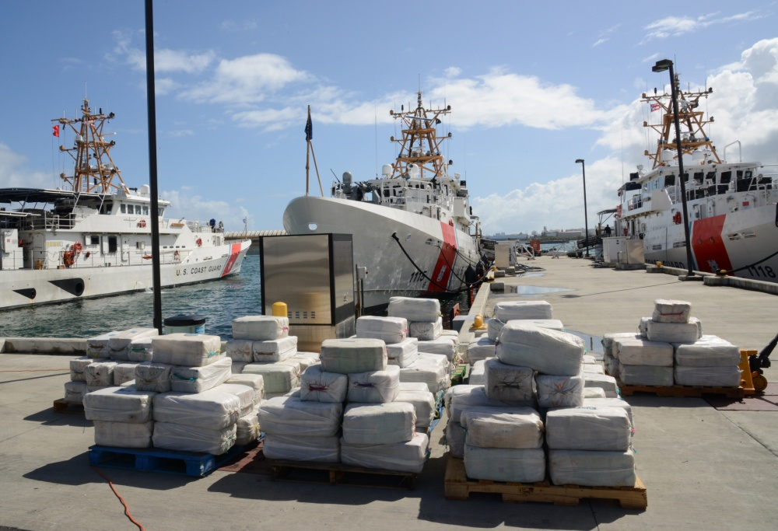
Cocaine load of Lady Michelle (NCA)

